

INTERNSHIP REPORT
Submitted to
SAVEETHA COLLEGE OF LIBERAL ARTS AND SCIENCES, SIMATS

SUBMITTED BY : RUCHITA MAARAN REGISTRATION NO : 252310022
BATCH : 2023- 2026

Under the guidance of

Dr. S. RUKMANI DEVI
Associate Professor, Department of
Computational Nexus

DEPARTMENT OF COMPUTER APPLICATIONS
SAVEETHA COLLEGE OF LIBERAL ARTS AND SCIENCES, SIMATS
SAVEETHA STREET, THANDALAM
CHENNAI – 602 105
SAVEETHA COLLEGE OF LIBERAL ARTS & SCIENCES SIMATS, DEEMED UNIVERSITY CHENNAI 602 105 DEPARTMENT OF COMPUTER APPLICATION

CERTIFICATE

This Report is prepared by Ruchita Maaran under the guidance of Dr. S. Rukmani Devi, Associate Professor, Department of Computational Nexus, SAVEETHA College, Chennai – 602 105. Based on the Internship work undergone by the student in the company. The Internal Examiner who conducted the Viva – Voce Examination for the award of marks as per the guidance laid down by the Saveetha College of Liberal Arts and Science, SIMATS has evaluated this report.

GUIDE STUDENT

Name: DR. S. RUKMANI DEVI Name: RUCHITA MAARAN

Signature: Signature:

INTERNAL EXAMINER

Signature:

ACKNOWLEDGEMENT

The successful accomplishment of this report is the outcome of the contribution of a number of people to whom we are grateful and thanked them from the very deep of my heart.

In the beginning, we would like to pay our humble gratitude to the almighty for giving us the ability to work hard under pressure.

First and foremost, I would like to express my deepest gratitude and special thanks to the University authorities for giving me this opportunity.

I take this opportunity to record my sincere thanks to Dr. GUNITHA ARUN CHANDHOK , Principal, SAVEETHA College (SCLAS) who has always been a source of inspiration in all our endeavors.

I would like to offer my sincere gratitude to Dr. S. RUKMANI DEVI, Associate professor, Department of Computational Nexus, for guiding me throughout the process in successful completion of my project and other faculty members of the Department of Computational Nexus whose guidance, inspiration and encouragement has helped a lot. I express my heartfelt thanks to them.

I would like to express my sincere thanks to ASCENDION ENGINEERING PRIVATE LIMITED for their cooperation and encouragement extended throughout the successful completion of the project.

INDEX

S.NO | DETAILS | PAGE NO.
1 | ABSTRACT | 5
2 | SYSTEM ANALYSIS | 7
3 | TECHNOLOGY | 9
4 | CODING | 11
5 | SCREENSHOT | 12
6 | BIBLIOGRAPHY | 19

ABSTRACT
Planning a road trip involves multiple complex decisions, choosing routes, estimating budgets, selecting accommodations, and personalising the experience based on individual travel preferences. Traditional planning methods are time-consuming and often result in either overspending or missing out on key experiences. The Road Trip Planner is an AI-powered web application built using Python and Streamlit that addresses these challenges by combining smart budget estimation, interactive data visualisation, and AI generated personalised itineraries into a single, easy-to-use interface.
The primary goal of this internship project was to develop a real-world Generative AI application that integrates OpenRouter's API to access large language models for intelligent trip planning. The application accepts user inputs such as starting city, destination city, travel mode, number of travellers, trip duration, and trip vibe, and instantly generates a cost breakdown, a pie chart visualisation of expenses, and a personalised day-by-day itinerary powered by the z-ai/glm-4.5-air model via OpenRouter.
Organization Information: Ascendion Engineering Private Limited is a technology services company specialising in engineering, AI, and digital transformation solutions. With the tagline 'Engineering to elevate life', Ascendion partners with leading enterprises to build innovative software products and platforms. The company brings together engineering expertise and AI capabilities to deliver impactful technology solutions across industries.
Programs and Opportunities: Ascendion Engineering Private Limited offers internship and development programs focused on Software Engineering, Generative AI, Machine Learning, and Cloud Technologies. Interns work on real-world projects alongside experienced engineers, gaining hands-on exposure to industry-grade tools, agile methodologies, and AI-driven product development. The organisation fosters a culture of continuous learning, innovation, and technical excellence.
Methodologies: Ascendion Engineering Private Limited follows an engineering-first, innovation-driven methodology where interns and engineers collaborate on real client projects from day one. The organisation encourages problem-solving, clean code practices, and AI integration across its development workflows.

Benefits of the Company/Institution through our Report: Ascendion Engineering Private Limited provide structured guidance, code reviews, and technical support, ensuring that every team member grows both technically and professionally.

SYSTEM ANALYSIS

Existing System:
- Traditional road trip planning relies on manually searching multiple websites for routes, hotels, and restaurants, a slow and disjointed process.
- Budget estimation tools are either too generic or require users to manually input every cost item.
- Existing travel apps lack personalisation — they do not adapt itineraries based on trip vibe, group size, or travel mode simultaneously.
- AI travel planners often depend on expensive closed-source APIs with rate limits and no offline flexibility.
- There is no single open-source tool that combines budget estimation, visual cost breakdown, and AI-generated itineraries in one interface.

Proposed System: The proposed Road Trip Planner is an AI-powered, interactive web application built with Streamlit and Python. It provides a unified interface where users can input their trip details, starting city, destination, travel mode, number of travellers, trip duration, and desired trip vibe, and instantly receive a complete trip plan.

The system automatically estimates total trip costs broken down by travel, accommodation, food, and miscellaneous expenses. A dynamic pie chart generated using Matplotlib visualises the cost distribution in real time. The AI trip plan feature uses OpenRouter's API to access the z-ai/glm-4.5-air model, generating a personalised, conversational day-by-day itinerary tailored to the user's budget, group size, and vibe — all within a single click. The system is privacy-preserving, using a locally deployed language model, and is open-source under the MIT License.
SOFTWARE REQUIREMENTS SPECIFICATIONS

SYSTEM CONFIGURATIONS: The software requirement specification can be produced at the culmination of the analysis task. The function and performance allocated to software as part of system engineering are refined By establishing a complete information description, a detailed functional description, a Representation of system behavior, and indication of performance and design constraints, Appropriate validate criteria, and other information pertinent to requirements.

SOFTWARE REQUIREMENTS:
SOFTWARE REQUIREMENTS | SPECIFICATION
Operating System | Windows 11
Programming Language | Python 3.10+
Web Framework | Streamlit
Data Library & Visualization | Pandas & Matplotlib
AI API | OpenRouter (z-ai/glm-4.5-air:free)
IDE | Visual Studio Code
Version Control | Git & GitHub
Deployment | Streamlit Community Cloud

HARDWARE REQUIREMENTS:
HARDWARE REQUIREMENTS | SPECIFICATION
Processor | Intel Core i3 or above
RAM | 8 GB minimum
Hard Disk | 500 GB
Internet | Required for OpenRouter API calls

TECHNOLOGY

Python
Python is a high-level, interpreted programming language known for its simplicity, readability, and versatility. It supports multiple programming paradigms including object-oriented, procedural, and functional programming. Python's extensive ecosystem of libraries makes it the go-to language for web development, data science, machine learning, and AI application development. In this project, Python serves as the core backend language connecting all components of the Road Trip Planner.

Streamlit
Streamlit is an open-source Python framework for building interactive web applications with minimal code. It allows developers to create data-driven apps entirely in Python, without requiring any frontend experience with HTML, CSS, or JavaScript. Streamlit provides built-in widgets like sliders, text inputs, radio buttons, and select boxes that enable real-time user interaction. In this project, Streamlit powers the entire UI, from the trip input panel to the budget breakdown and AI plan display.

Pandas
Pandas is a powerful Python library for data manipulation and analysis. It provides DataFrame and Series structures for handling tabular data efficiently. In this project, Pandas is used to construct and display the budget breakdown table, organising cost categories (Travel, Accommodation, Food, Miscellaneous) and their calculated values into a clean, readable table format within the Streamlit interface.

Matplotlib
Matplotlib is a comprehensive Python library for creating static, animated, and interactive visualisations. It supports a wide range of chart types including line charts, bar charts, scatter plots, and pie charts. In this project, Matplotlib is used to generate a dynamic pie chart that visually represents the distribution of trip costs across all four budget categories — giving users an immediate graphical overview of where their money goes.

OpenRouter API
OpenRouter is a unified API gateway that provides access to over 400 large language models through a single, OpenAI-compatible interface. It offers automatic provider routing, fallback support, and edge-based inference for low-latency responses. In this project, OpenRouter is used to access the z-ai/glm-4.5-air:free model for generating AI-powered trip plans. The API returns personalised, conversational itineraries based on the user's trip inputs, budget, and vibe preference.

Z.ai GLM-4.5-Air Model
The z-ai/glm-4.5-air model is a high-performance, free-tier language model available via OpenRouter. It is optimised for conversational tasks with low latency (approximately 2.5 seconds) and edge-based inference. The model generates natural, practical, and concise trip plans based on structured prompts, including route summaries, day-by-day itineraries, budget tips, and vibe-matched activity suggestions. Its free tier access makes it ideal for student and open-source projects.

Git & GitHub
Git is a distributed version control system used to track changes in project files throughout development. GitHub was used as the remote repository hosting platform, enabling project sharing and public access. The Road Trip Planner project is published at https://github.com/WisteriaM7/ROAD-TRIP-PLANNER under the Apache License 2.0, making it accessible for the open-source community.

CODING
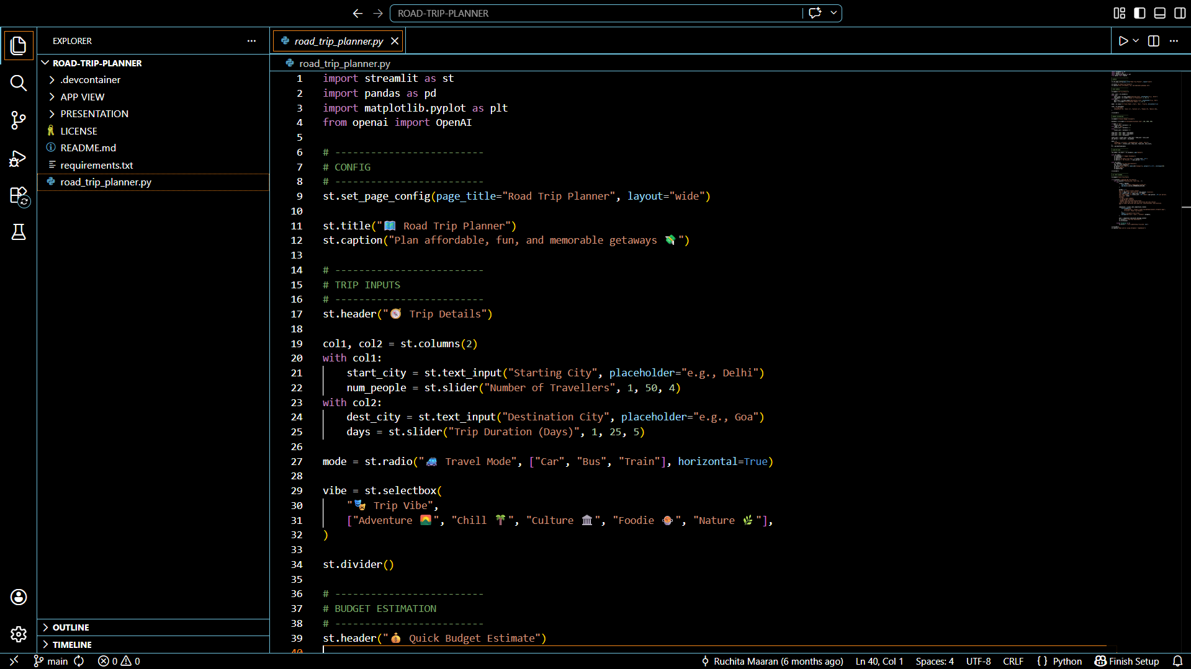
The Above coding snippet represents the Python Code on VSCode IDE for creating the Road Trip Planner.
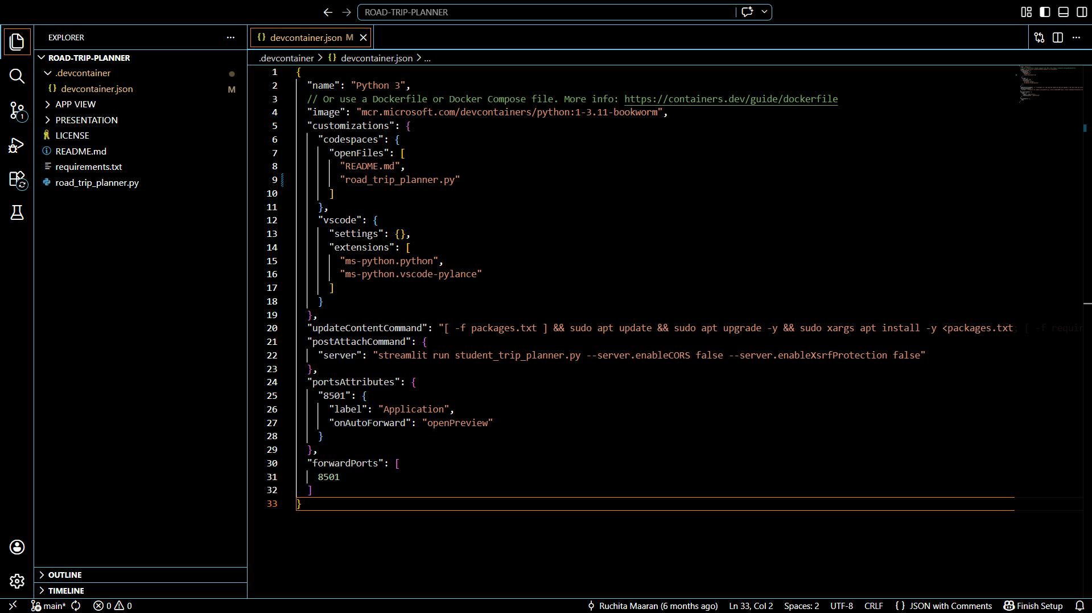
The Above Snippet represents the JavaScript JSON Code File Structure on Implementing the Planner agent for road trips & getaways.

SCREENSHOT
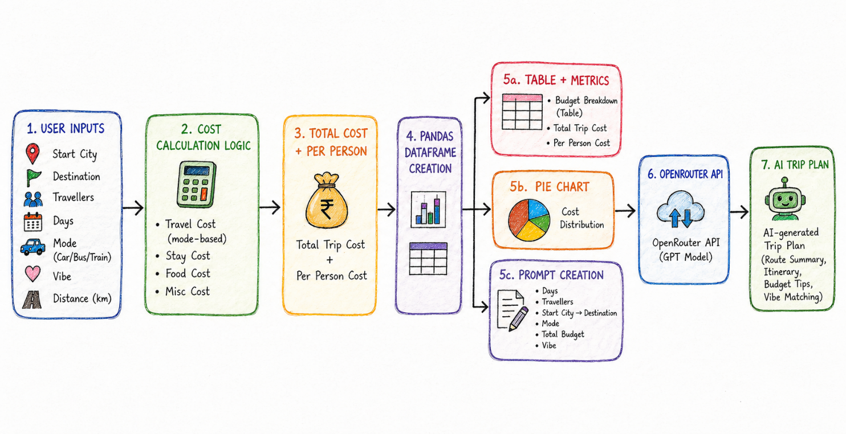
The Above Screenshot is the workflow of the Streamlit Application, with the specified modules used.
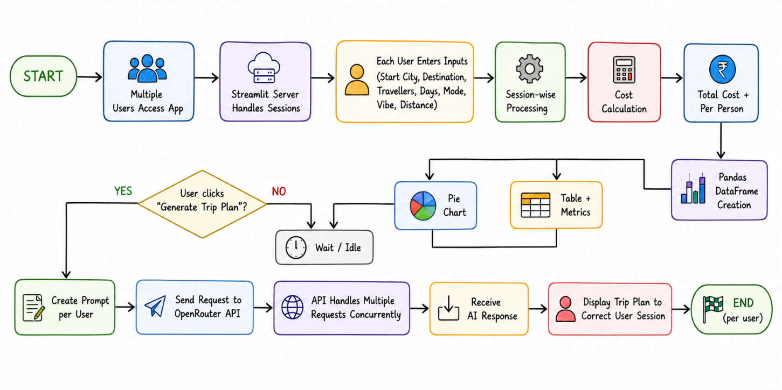

The Above Screenshot resembles the Flowchart of the Application for multiple sessions in one link as the cloud is free.

Output Screenshot 1 — Application Home Page and Trip Input Panel
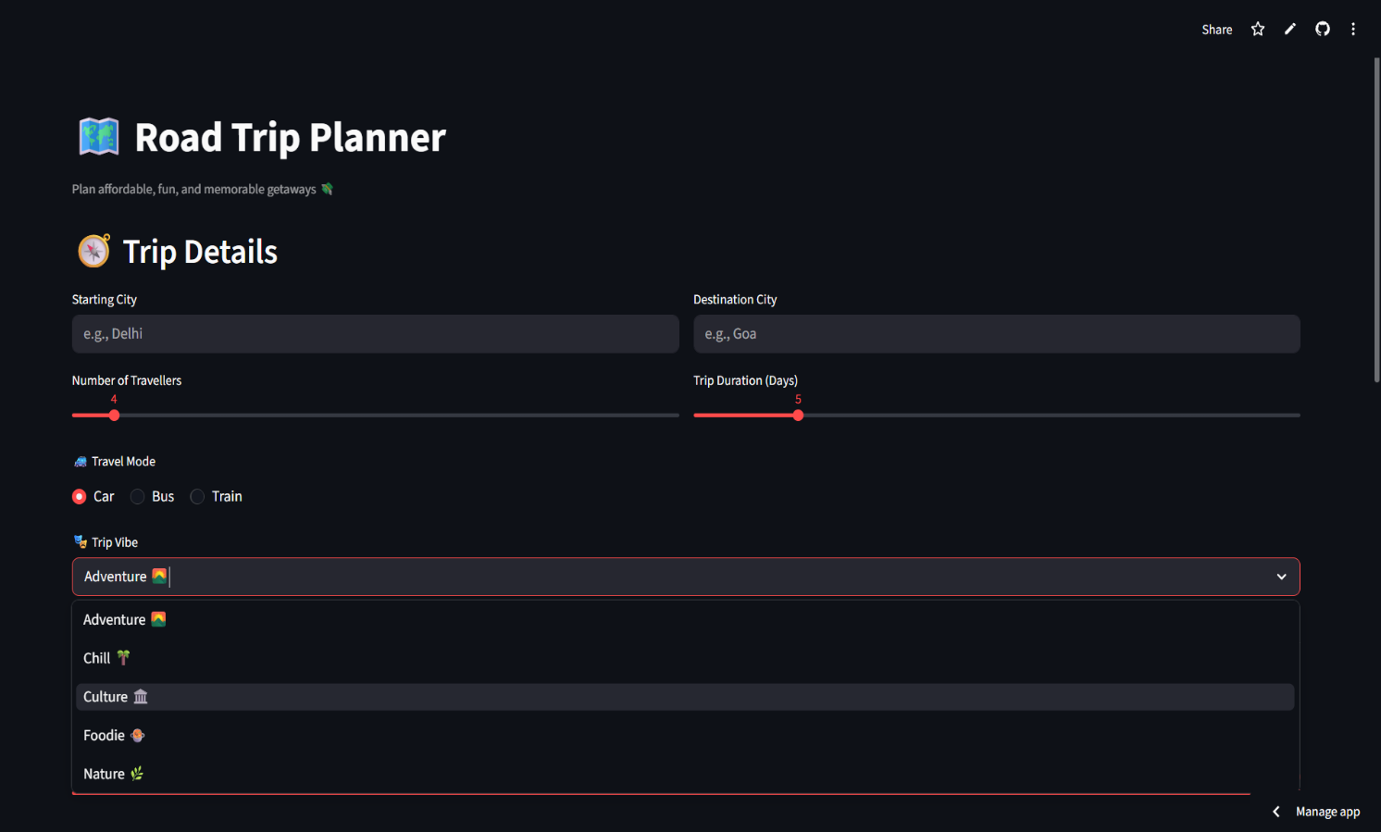

The application home page presents a clean, wide-layout interface built entirely with Streamlit. The Trip Details section uses a two-column layout to collect the starting city, destination city, number of travellers, and trip duration. The travel mode is selected via a horizontal radio button, and the trip vibe is selected from a dropdown menu. All inputs are interactive and update the budget calculation in real time.

Output Screenshot 2 — Budget Breakdown Table and Cost Distribution Chart
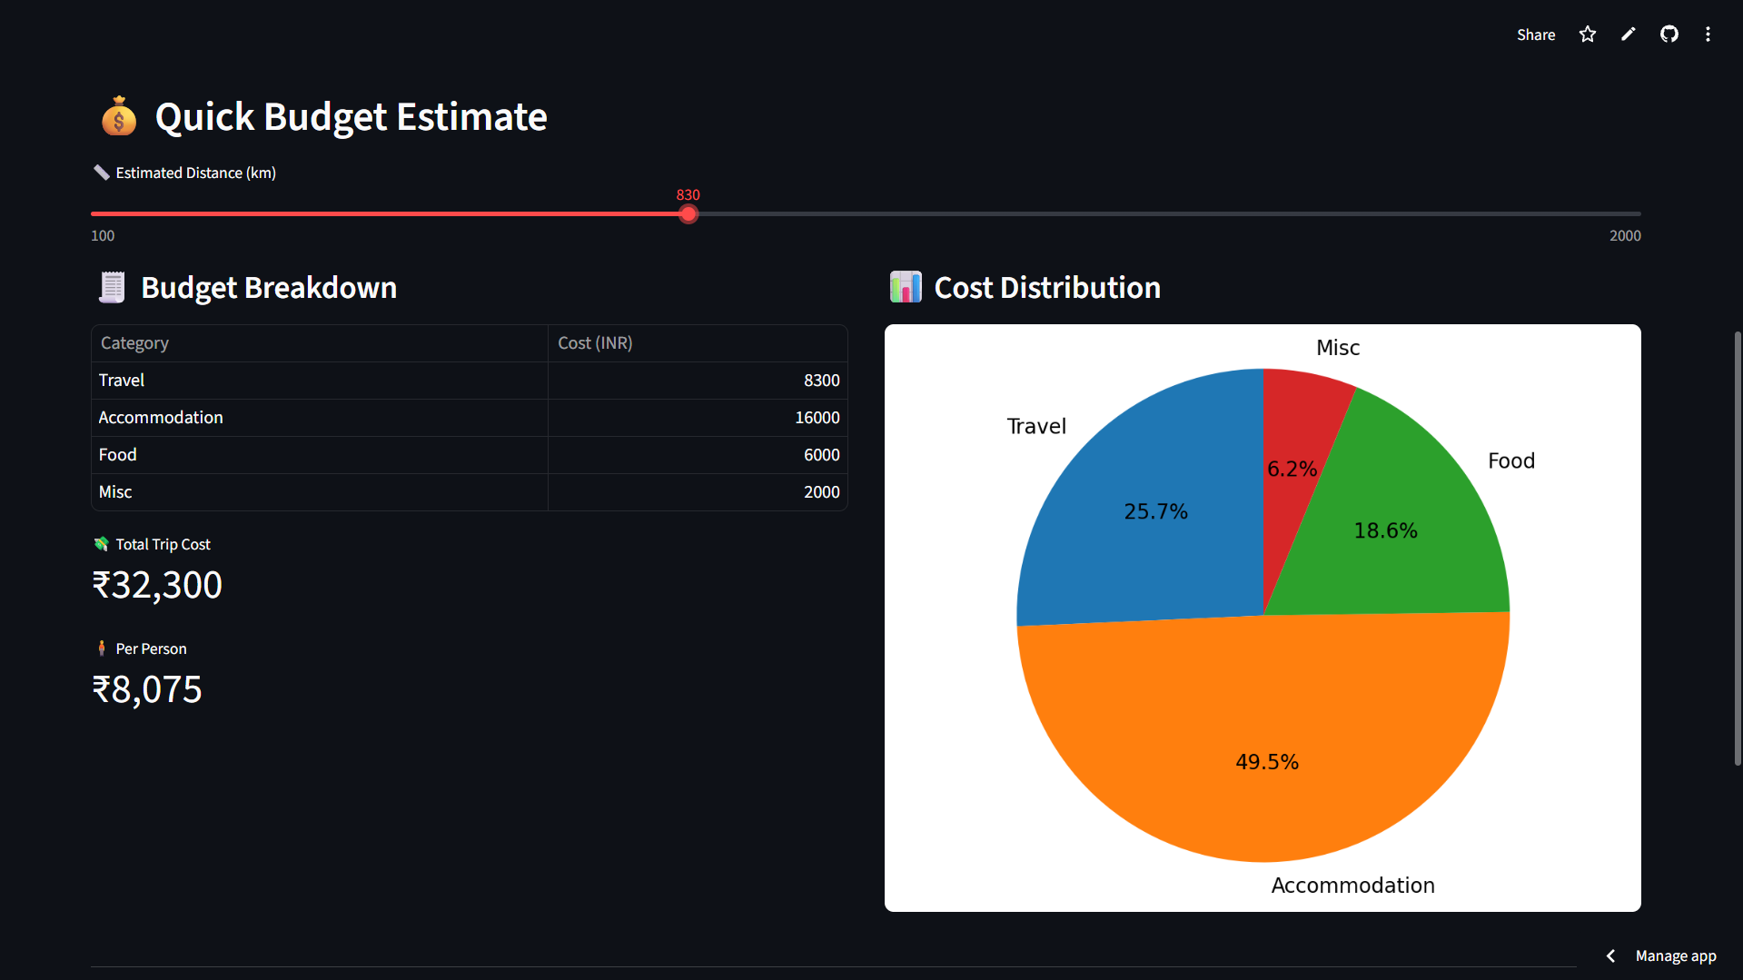

The budget section is displayed in a two-column layout. The left column shows a structured Pandas DataFrame table listing each cost category alongside its calculated value in Indian Rupees. Below the table, two Streamlit metric widgets display the total trip cost and per-person cost prominently. The right column renders a Matplotlib pie chart visualising the proportional distribution of costs across all four categories — making budget allocation immediately visible at a glance.

Output Screenshot 3 — AI Trip Plan Output (NYC – Sydney)

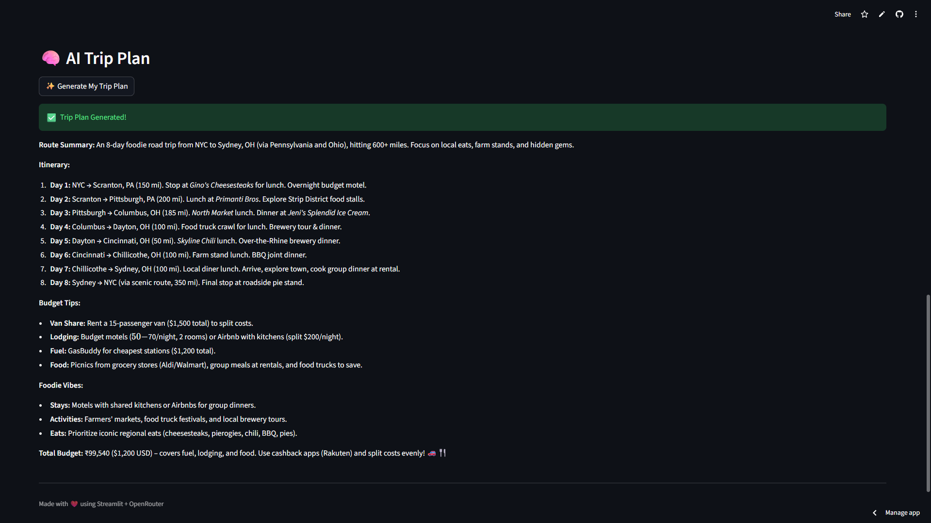

When the user clicks the 'Generate My Trip Plan' button, the application displays a loading spinner while the AI model processes the request. The OpenRouter API sends the structured prompt to the z-ai/glm-4.5-air model, which generates a complete, personalised trip plan in under 3 seconds. The output includes a route summary, a day-by-day itinerary with activity suggestions, budget-saving tips, and recommendations tailored to the selected trip vibe and travel mode.
Output Screenshot 4 — AI Trip Plan Output (Chennai – Kolkata)
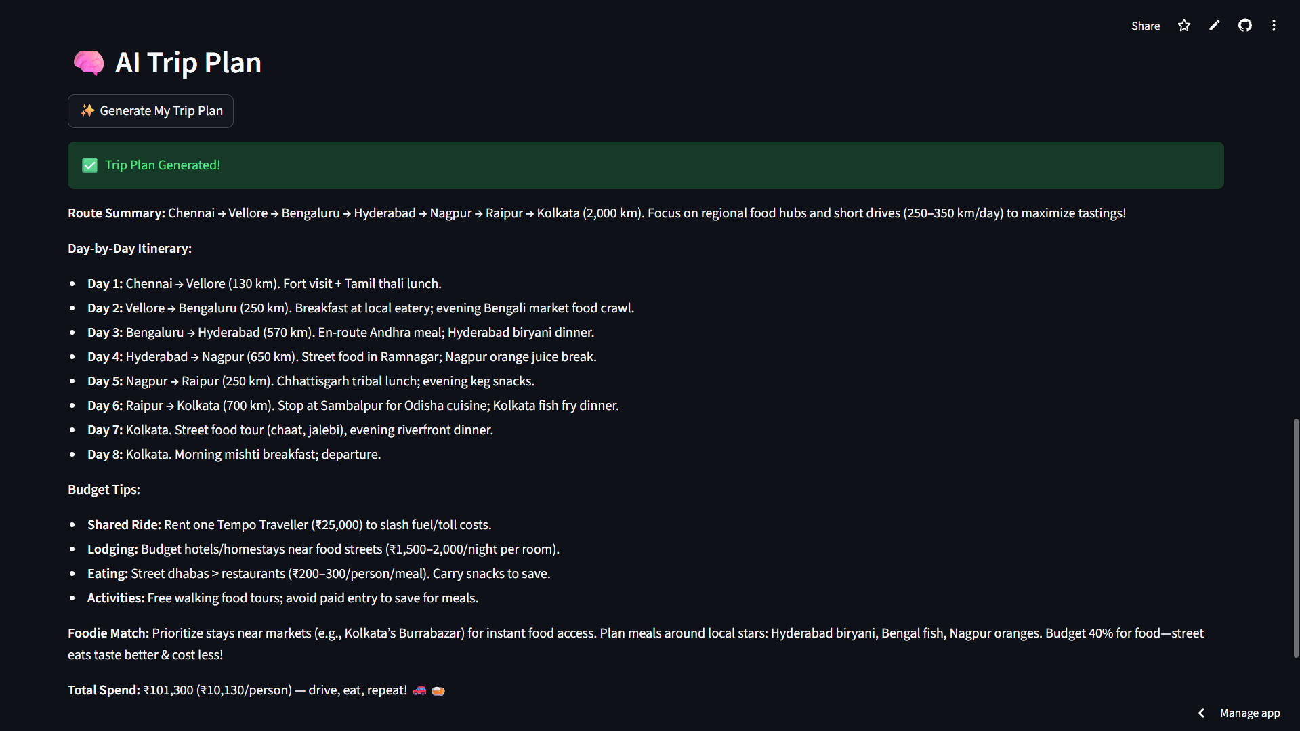

Output Screenshot 5 – Logs for App Management

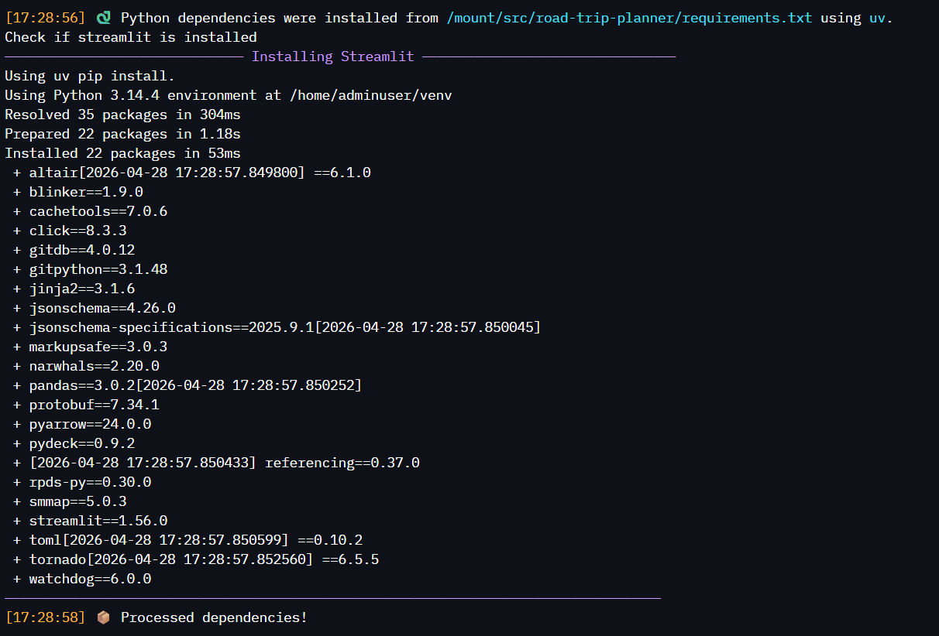

The Above Log Page is how the source control of the app under the creator, showcases the dependencies required to run after the trip has been processed..

CONCLUSION

This internship project has been a deeply rewarding experience that brought together multiple dimensions of modern software development — Python programming, web application design with Streamlit, data handling with Pandas, data visualisation with Matplotlib, and Generative AI integration through OpenRouter. Building the Road Trip Planner gave me practical, hands-on exposure to the full lifecycle of a real-world AI application — from ideation and UI design to API integration and cloud deployment.

The project demonstrated how Generative AI can be meaningfully applied to everyday problems. Rather than simply querying an AI model, the Road Trip Planner wraps the AI in a fully interactive application that takes structured user inputs, computes dynamic budget estimates, renders real-time visualisations, and delivers personalised travel plans — all within a single Python file and a clean Streamlit interface.

One of the key technical learnings from this project was understanding API ecosystems for large language models. Using OpenRouter's unified gateway gave me insight into how production AI systems handle model routing, fallback mechanisms, and cost optimisation across multiple providers. The z-ai/glm-4.5-air model's free tier also demonstrated that capable AI can be integrated into student projects without financial barriers.

Beyond technical skills, this internship at Ascendion helped me develop professional habits, writing clean, maintainable code; structuring projects for public GitHub repositories with proper documentation; and deploying applications on cloud platforms for real-world accessibility. These experiences have prepared me well for the industry.

Overall, the Road Trip Planner stands as a complete, functional, and publicly deployed AI-powered application — a strong demonstration of the skills developed during this internship and throughout the Generative AI .

BIBLIOGRAPHY

Web Links:

- Streamlit Documentation — https://docs.streamlit.io
- Pandas Documentation — https://pandas.pydata.org/docs
- Matplotlib Documentation — https://matplotlib.org/stable/contents.html
- OpenRouter API — https://openrouter.ai
- OpenAI Python SDK — https://github.com/openai/openai-python
- Z.ai GLM Model — https://openrouter.ai/z-ai/glm-4.5-air
- GitHub — https://github.com
- Streamlit Community Cloud — https://streamlit.io/cloud
- Python Official Documentation — https://docs.python.org/3

Project Links:

- Road Trip Planner GitHub: https://github.com/WisteriaM7/ROAD-TRIP-PLANNER
- Live App: https://road-trip-getaway-planner.streamlit.app

